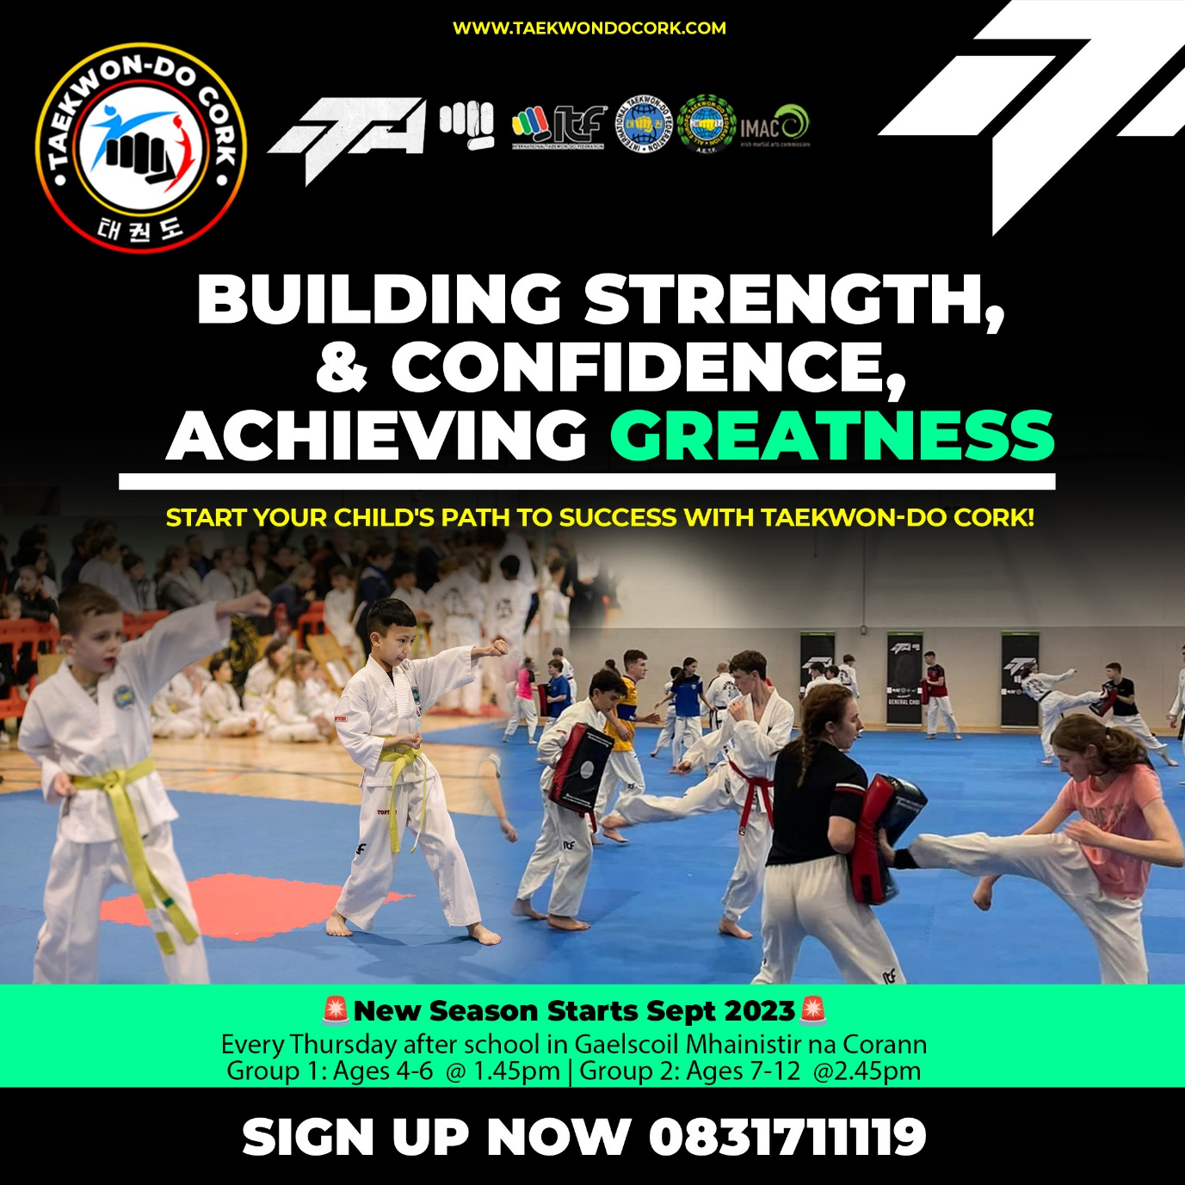

Hey Parents of Gaelscoil Mhainistir na Corann,
Darren from Taekwon-Do Cork here. Hope you're all doing well!
Last year, we had such a fantastic time working with the kids at Gaelscoil Mhainistir na Corann. It was genuinely heartwarming to see their growth, not just in Taekwon-Do, but in their confidence and camaraderie too.
As we get ready for this year, I'm excited to let you know that along with our usual 2.45pm class on Thursdays for the 7-12 age group, we're starting a new session at 1.45pm for the younger ones, aged 4-6.
Here are some of the benefits kids experience with us:
Improved physical fitness and strength
Confidence from learning self-defense techniques
Greater self-esteem
Enhanced interpersonal skills
The joy of achievement through our belt system
If you're thinking of enrolling your child or have friends who might be interested, please give me a shout at 0831711119 or check out our website at taekwondocork.com.
Thanks for all your support, and looking forward to another great year!
Best, Darren

